

FACULTY OF TECHNOLOGY AND ENGINEERING
DEVANG PATEL INSTITUTE OF ADVANCE TECHNOLOGY AND RESEARCH
DEPARTMENT OF INFORMATION TECHNOLOGY

A.Y. 2026-27 [ODD]
LAB MANUAL
CSUC201: DSA



Practical 4
Practical 4.1
A hospital manages a queue of patient tokens. New critical patients must be added to the front, routine patients are added to the end, and occasionally a patient with a priority number must be inserted at a specific position in the queue. Given a sequence of such operations, implement all three insertion types and print the final queue after each operation.

Code :
https://github.com/vaidik5646/FDSA-BATCH-A/tree/main/practical4

Output :
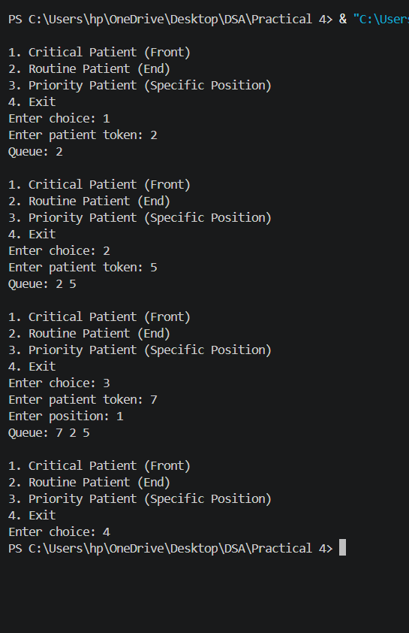
Problem Faced :
In this Practical , I faced problem to give next node after creating node and also faced problem to add node at specific point and to link two node after creating new node.

Key Question :
[Problem 1] Inserting at a position beyond the current length of the list is an invalid operation. Should your solution silently insert at the end, report an error, or do something else entirely? Justify your choice and explain what assumption about the caller your choice makes.
If the position given is greater than the current length of the linked list, the operation is considered invalid. My solution explicitly checks the position and reports an error instead of silently inserting the new patient at the end. This is a better approach because it prevents incorrect input from being hidden and ensures that the requested position is followed correctly. It assumes that the caller is responsible for providing a valid position, and if an invalid position is provided, the program informs the caller rather than causing an error or changing the requested operation.

Practical 4.2
The hospital also needs to remove a patient token from the queue when a patient leaves, print all remaining tokens from last to first for an end-of-day audit, and display the full queue from front to back at any point. Implement deletion by value, reverse printing, and forward traversal on the same queue from Problem 4.1a.

Code :
https://github.com/vaidik5646/FDSA-BATCH-A/tree/main/practical4
Output :
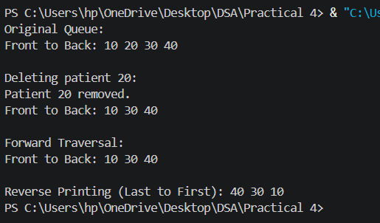

Problem faced :
In this Practical , I faced problem to give next node after deleting node and also faced problem to link two node after deleting new node.

Key Question :
The hospital also needs to remove a patient token from the queue when a patient leaves, print all remaining tokens from last to first for an end-of-day audit, and display the full queue from front to back at any point. Implement deletion by value, reverse printing, and forward traversal on the same queue from Problem 4.1a.
If the node to be deleted is the only node in the list, only one pointer, the head pointer, needs to change, and it must be set to NULL because the list becomes empty. This is structurally different from deleting a node in the middle, where the next pointer of the previous node must be changed to point to the node after the deleted node. In the single-node case, there is no previous or next node, so we simply make head = NULL and delete the node.

